|  |  |  |  |
| --- | --- | --- | --- |
|  | | | |
| **Expt. No:** | | **6** | **Diode Clipper Circuits (Series – Configuration)** |
|  | | |
| **Date:** | **17/09/2020** | |
|  | | | |

**Aim:**  To study, design and plot the various series diode clipper circuits.

**SOFTWARE TOOLS / OTHER REQUIREMENTS:**

1. Multisim Simulator/Circuit Simulator

# Theory:

We know that when a diode is forward biased it allows current to pass through itself clamping the voltage across it to 0.7 volts (Practical Silicon Diode). While, when it is reverse biased, no current flows through it and the voltage across its terminals is unaffected, and this is the basic operation of the diode clipping circuit.

***Clippers are networks that employ diodes to “clip” away a portion of an input signal without distorting the remaining part of the applied waveform.***

There are two general categories of clippers: ***Series***and ***Parallel****.* The series configuration is defined as the one where the diode is in series with the load, whereas the parallel variety has the diode in a branch parallel to the load.

**series configruations**

**negative clipper**



As shown above, when the positive half cycle appears, the diode being forward biased, acts as short circuit and allows the input voltage to appear across the load resistor. During the negative half cycle, the diode is reverse biased, acts as open circuit and hence we see that there is no connection between the output and input node, thereby the output voltage level remains at zero. Since the negative cycle of the input is getting clipped-off, the configuration in the above circuit is known as negative clipper.

Likewise when the polarity of the diode is reversed, we can clipp-off the positive half of the input cycle. In this case, during the positive half cycle, the diode remains reverse biased thereby disconnecting the output node from input node and the output voltage level remains at zero. But when the negative half cycle appears, the diode gets forward biased and allows the entire input to appear across the output load resistance.

**few series diode clipper configurations**

**positive**



**negative**



**1.) Negative CLipper**

**Circuit/connection diagrams (fROM multisim)**

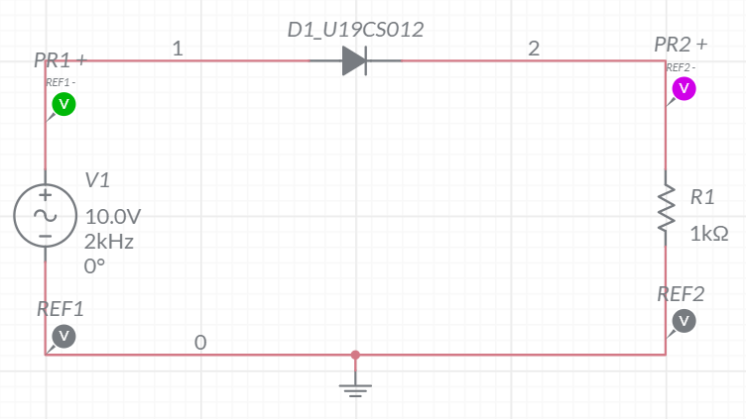

**waveforms (fROM multisim)**

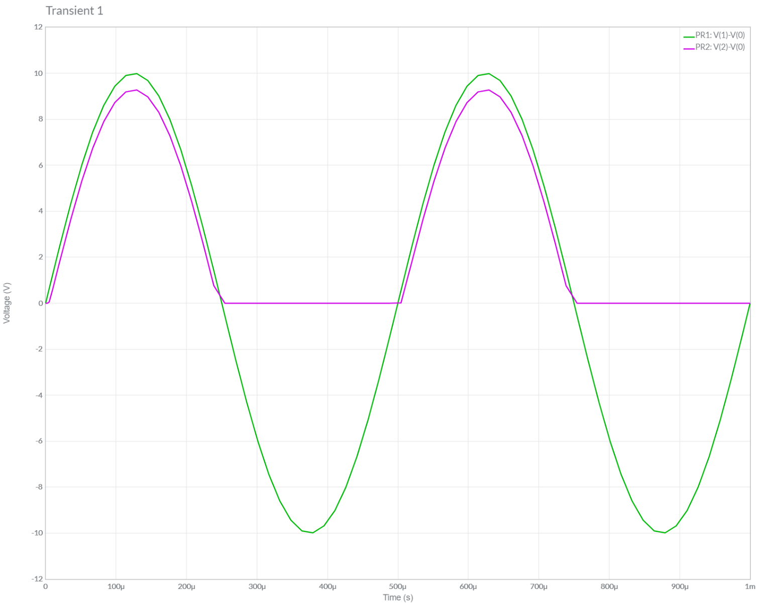

**2.) POSITIVE CLipper**

**Circuit/connection diagrams (fROM multisim)**

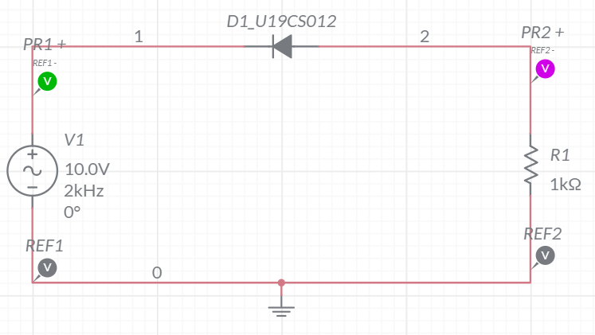

**waveforms (fROM multisim)**

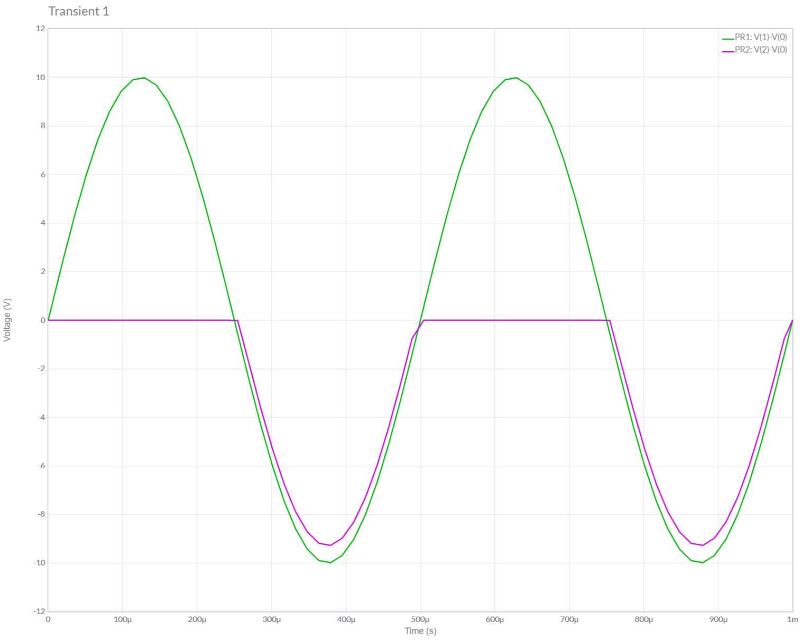

**3.) Negative CLipper WITH BIAS-I**

**Circuit/connection diagrams (fROM multisim)**

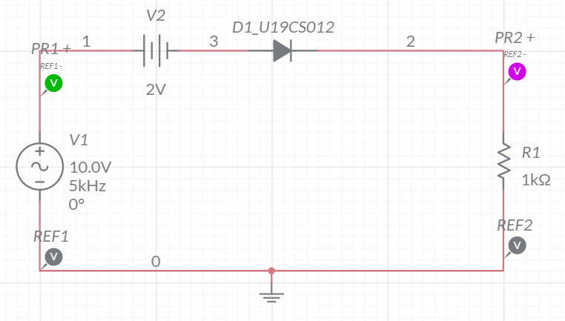

**waveforms (fROM multisim)**

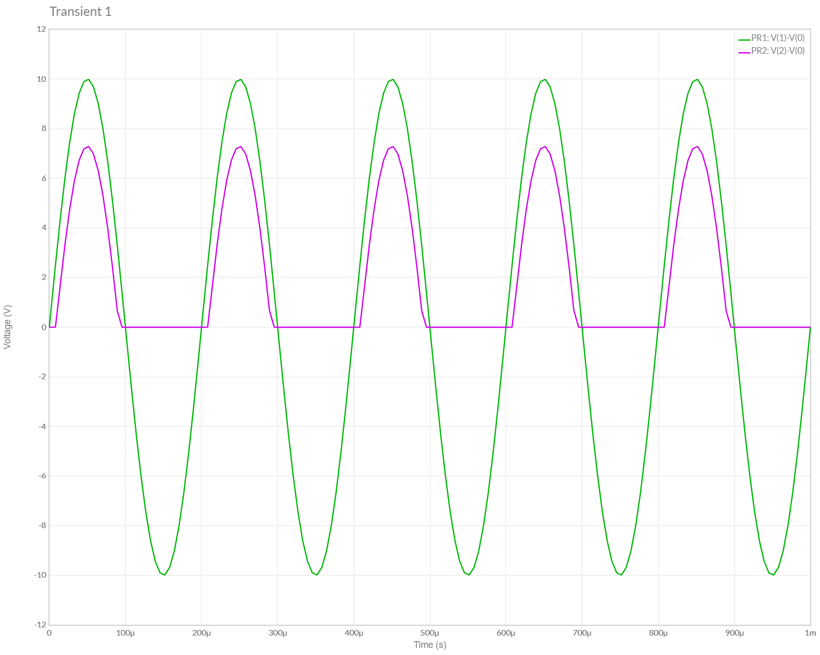

**4.) Negative CLipper WITH BIAS-II**

**Circuit/connection diagrams (fROM multisim)**

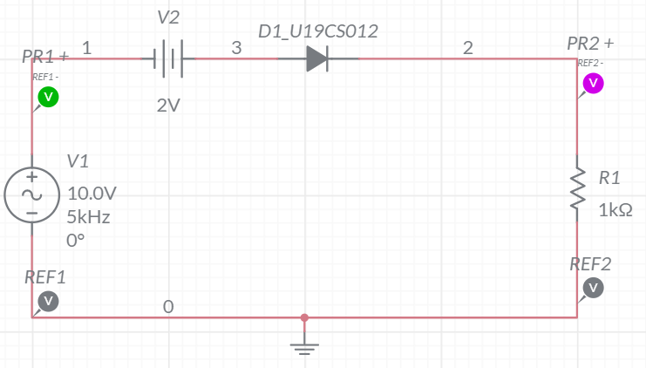

**waveforms (fROM multisim)**

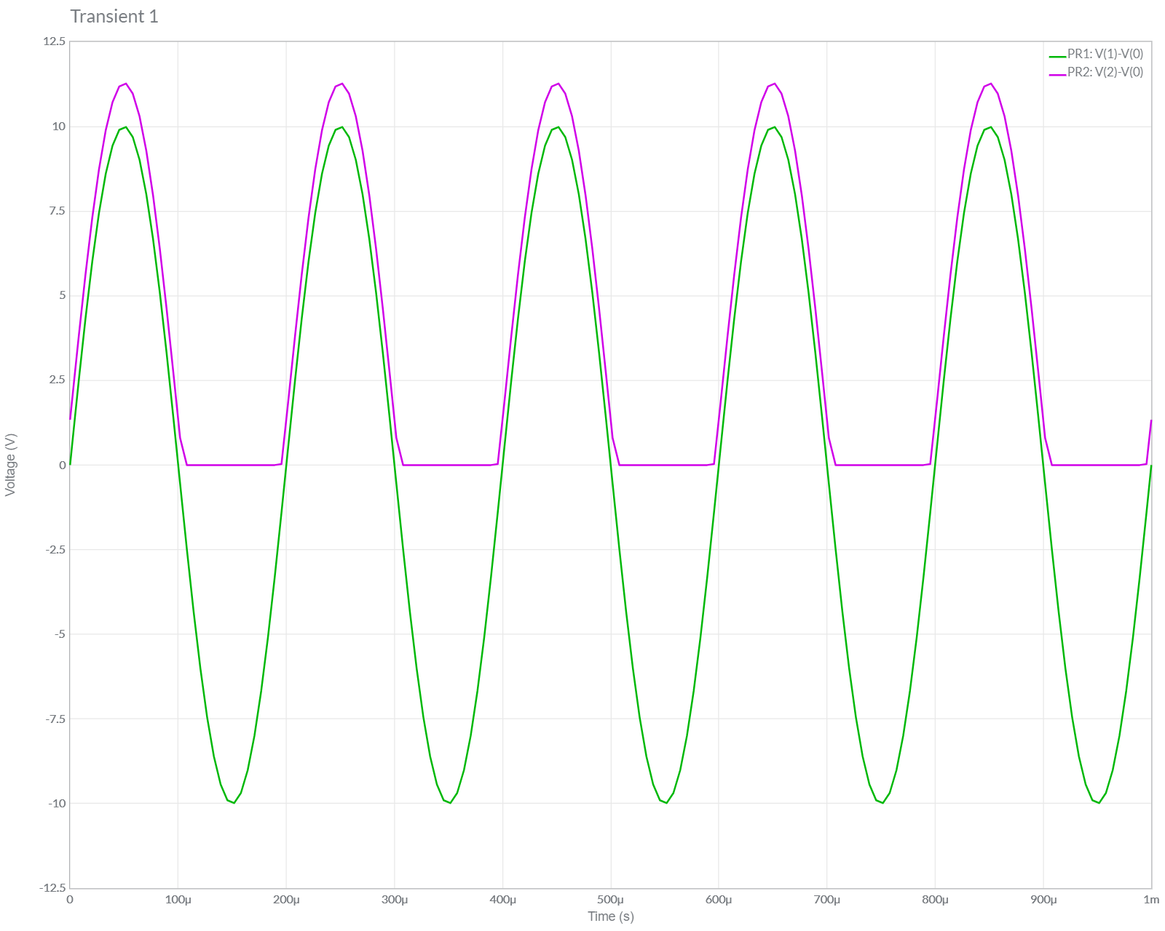

**5.) POSITIVE CLipper WITH BIAS-I**

**Circuit/connection diagrams (fROM multisim)**

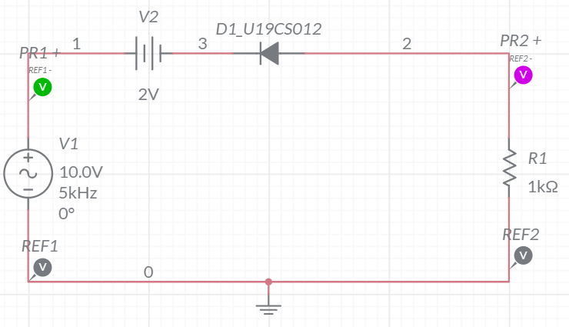

**waveforms (fROM multisim)**

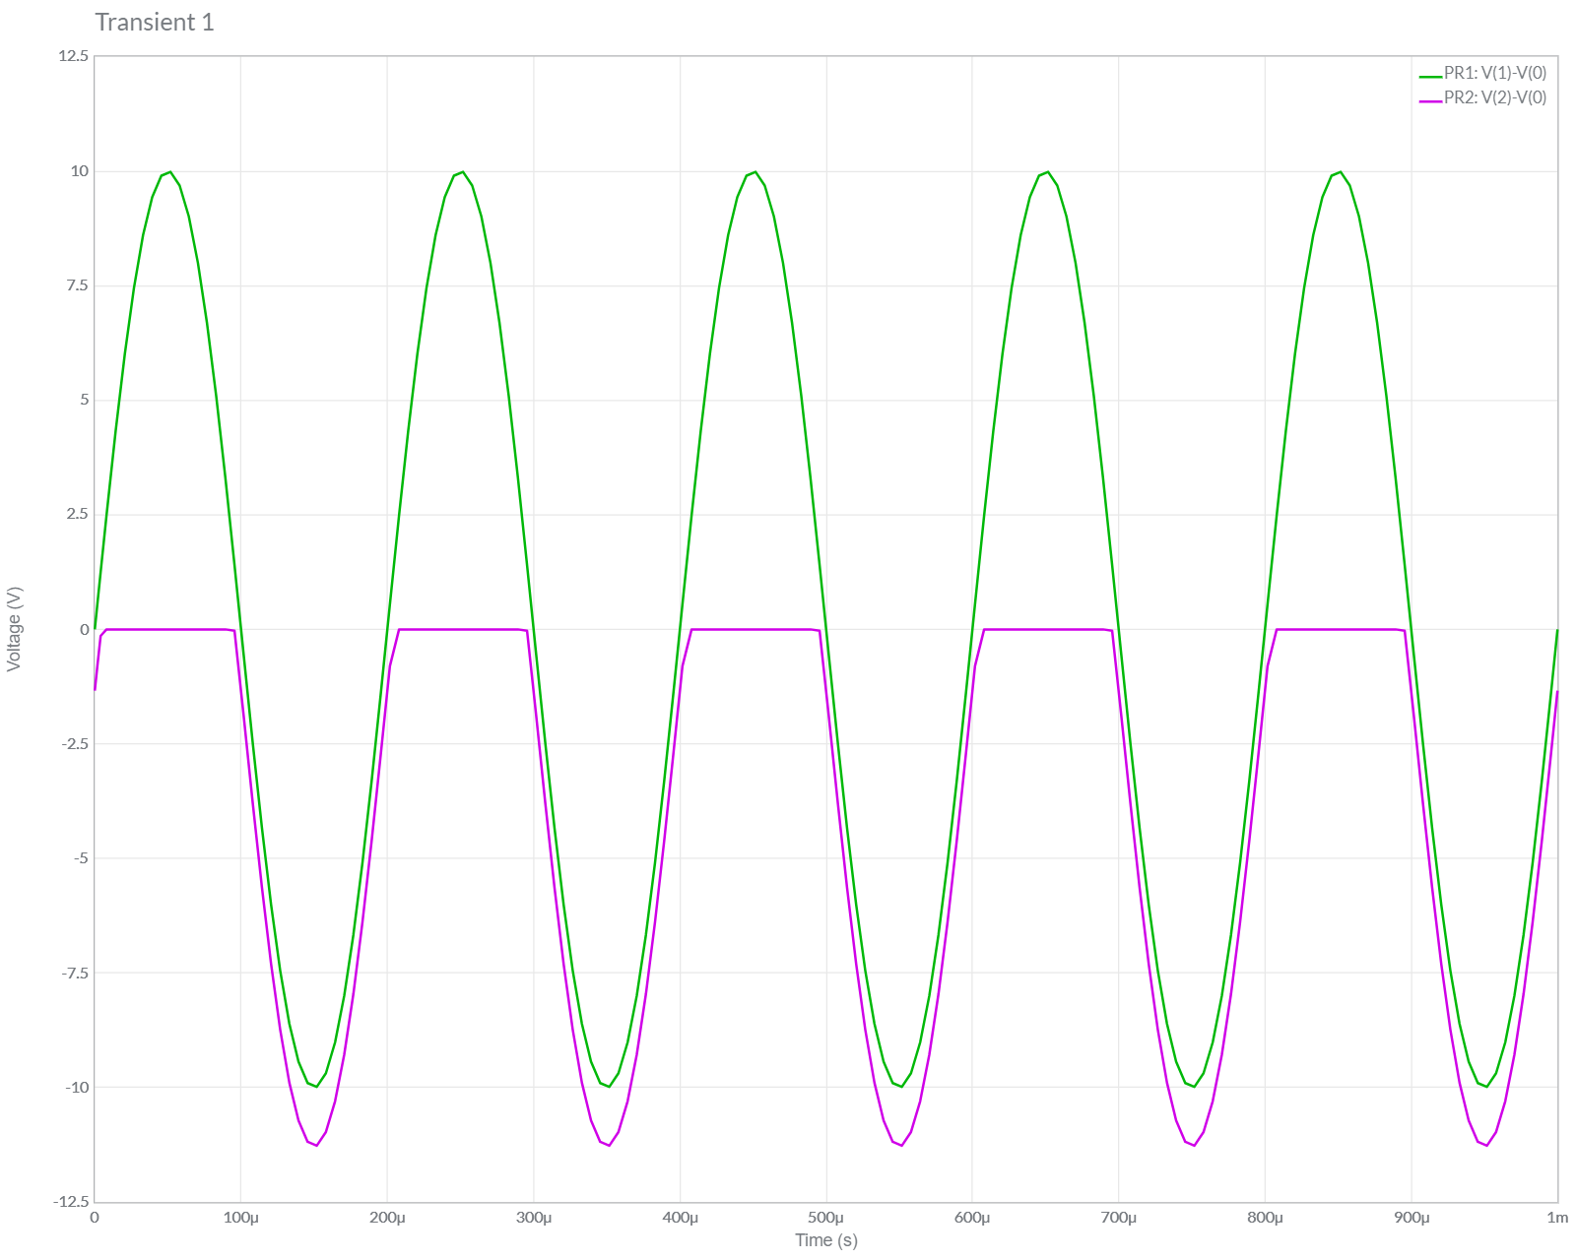

**6.) POSITIVE CLipper WITH BIAS-Ii**

**Circuit/connection diagrams (fROM multisim)**

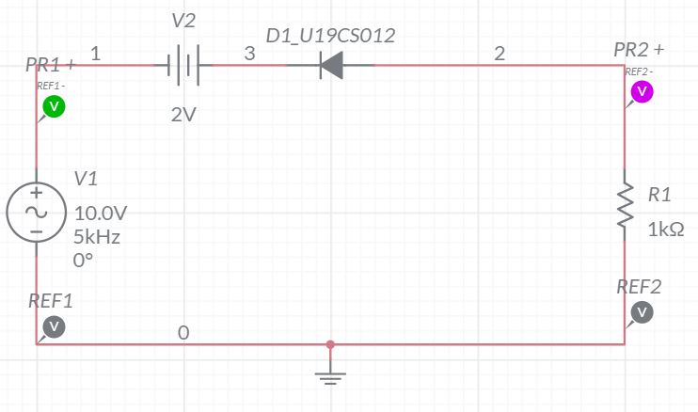

**waveforms (fROM multisim)**

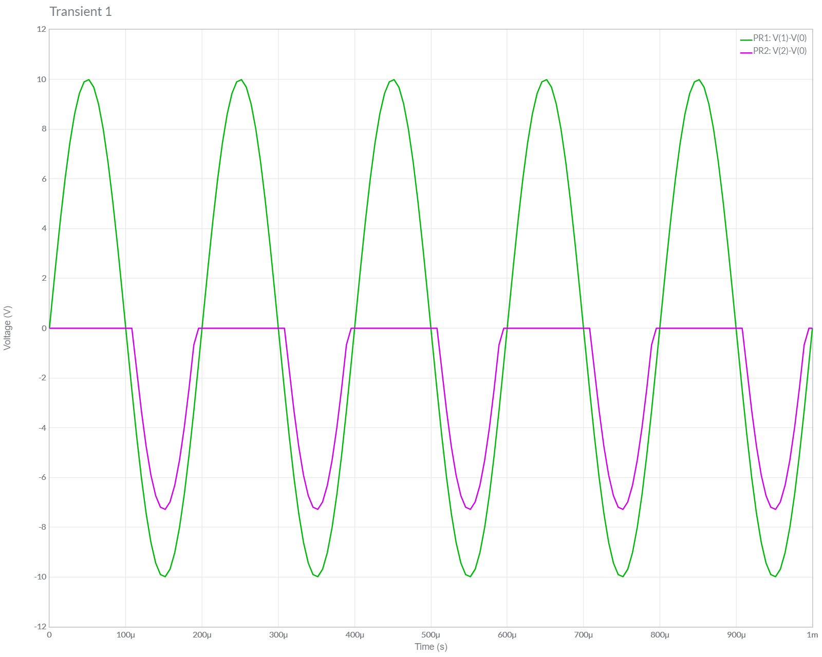

**Conclusions**

1.) In this Experiment, We have studied about Clipper Circuits [Both Positive and Negative] along with Different Biasing Applied.

2.) We Verified the Theoretical Knowledge of Series Clippers by Performing Simulations of 6 Cases of Clippers in Series in Multisim.

3.) Hence, we have Successfully Designed, Plotted and Verified Various Series Diode Clipper Circuits.

**ASSIGNMENT-6**

U19CS012

**1.** Determine and plot the output voltage for the given circuit. Also verify the same using Multisim.



(I) Multisim Calculations:

*1.) Circuit Image:*

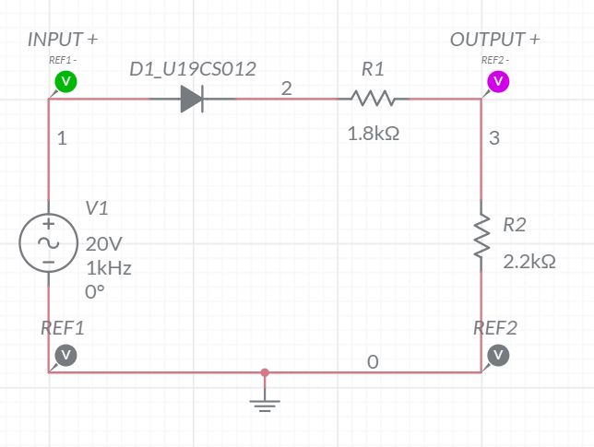

*2.) Grapher Image:*

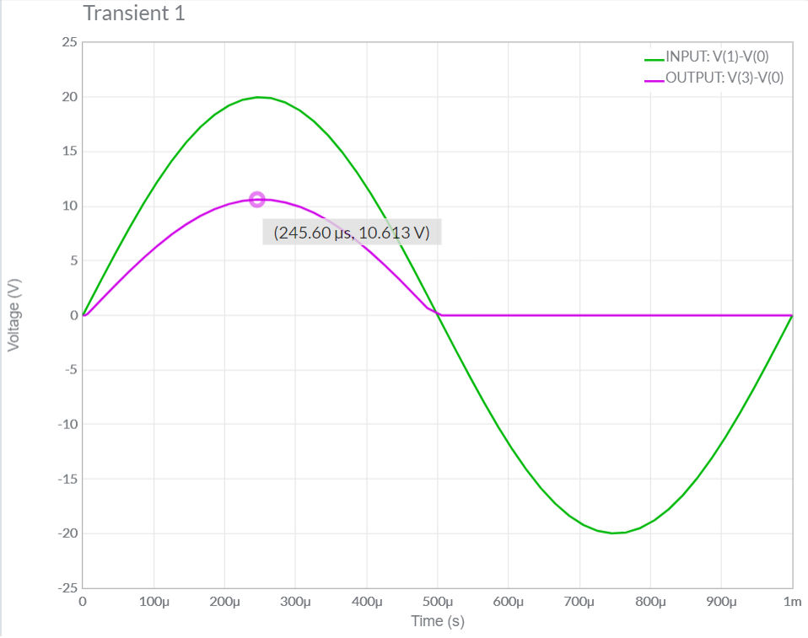

(II) Theoretical Calculations:

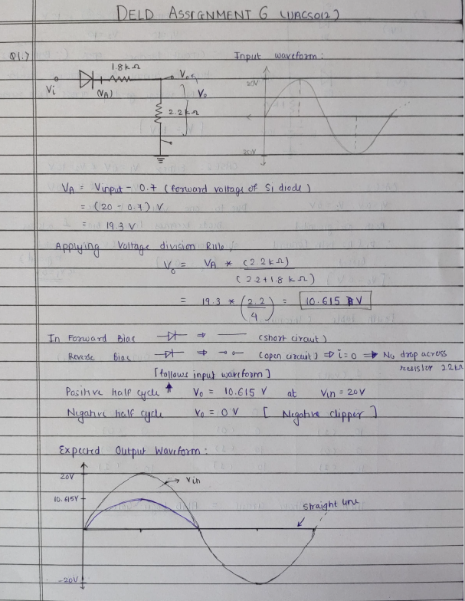

**2.** Identify the type of Logic Gate implemented by the below diode configuration. Also verify it using Multisim.



A.) Multisim Calculations:

*1.) Circuit Image:*

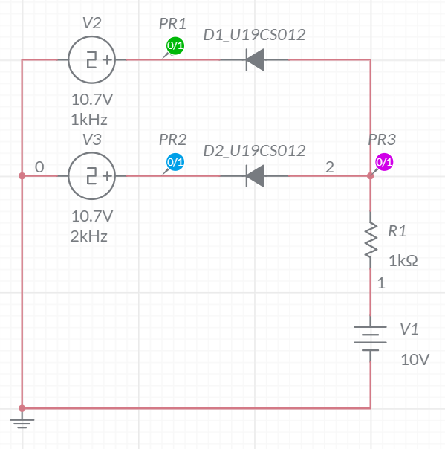

*2.) Grapher Image:*

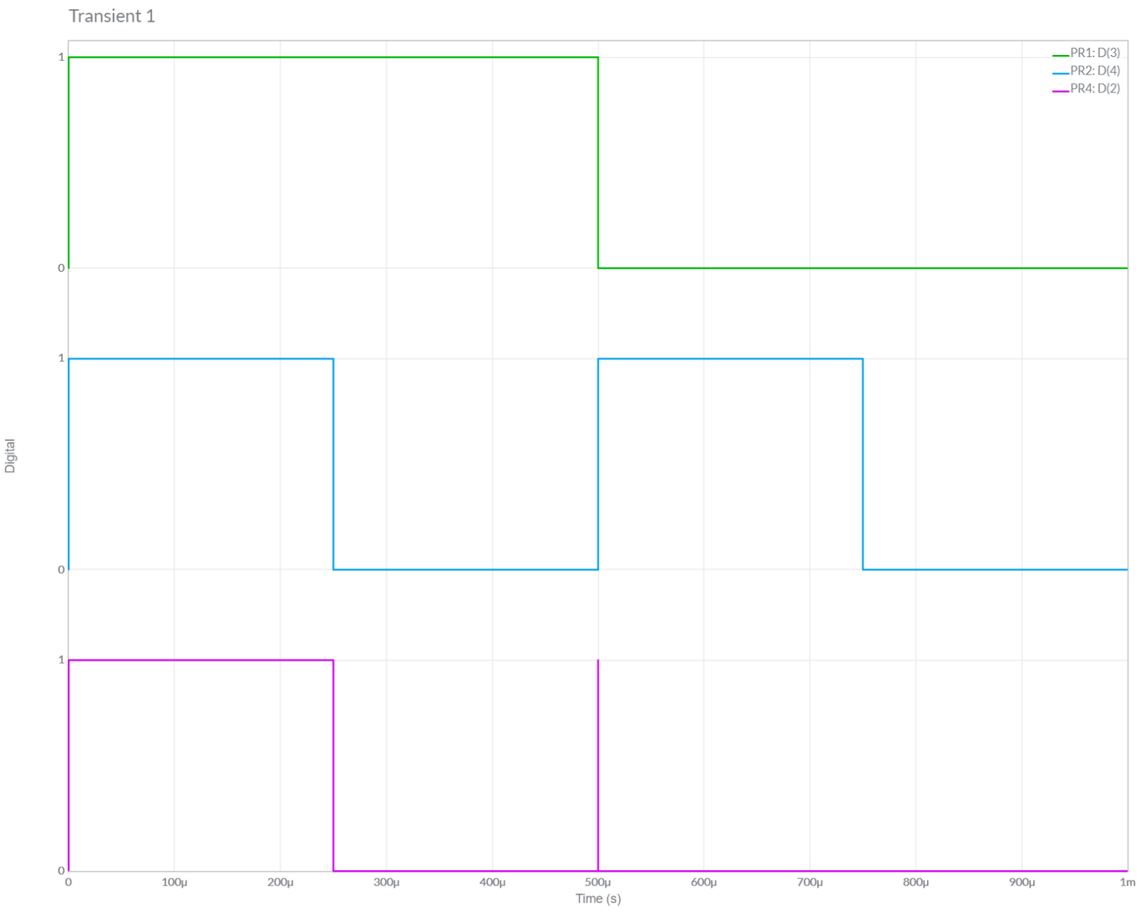

It Follows the Truth Table of AND Gate. [From Above Graph]

B.)Theoretical Calculations:

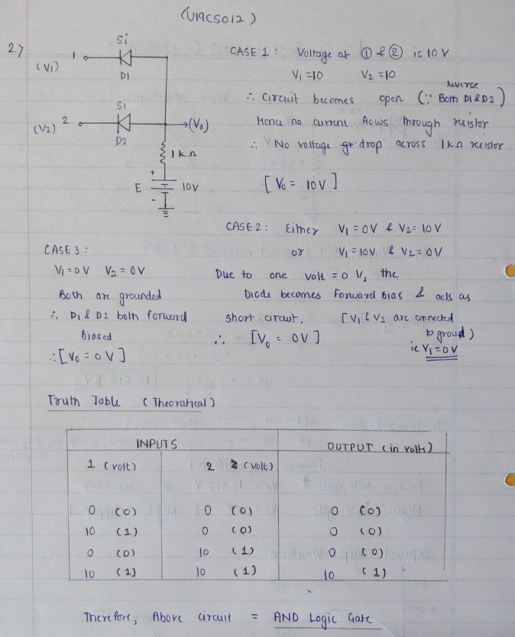

Hence, Circuit is Verified Successfully both theoretically & practically.

**3.** Draw the transfer characteristics for all the clipper configurations which are part of your today’s practical (Practical – 6).



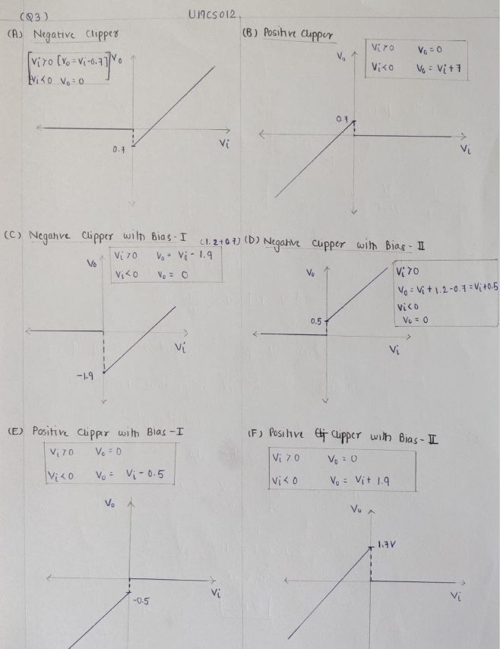

**4.** Assuming Symmetrical Sine wave input with peak value greater than the reference voltage, predict the output and plot the Transfer Characteristics for the following Clipper Circuits:

A.)



I.)Theoretical Calculations:

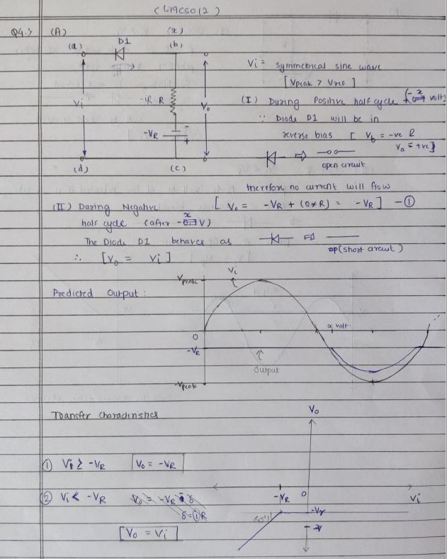

*1.) Circuit Image:*

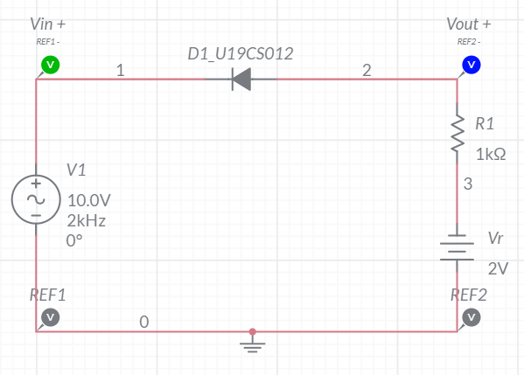

*2.) Grapher Image:*

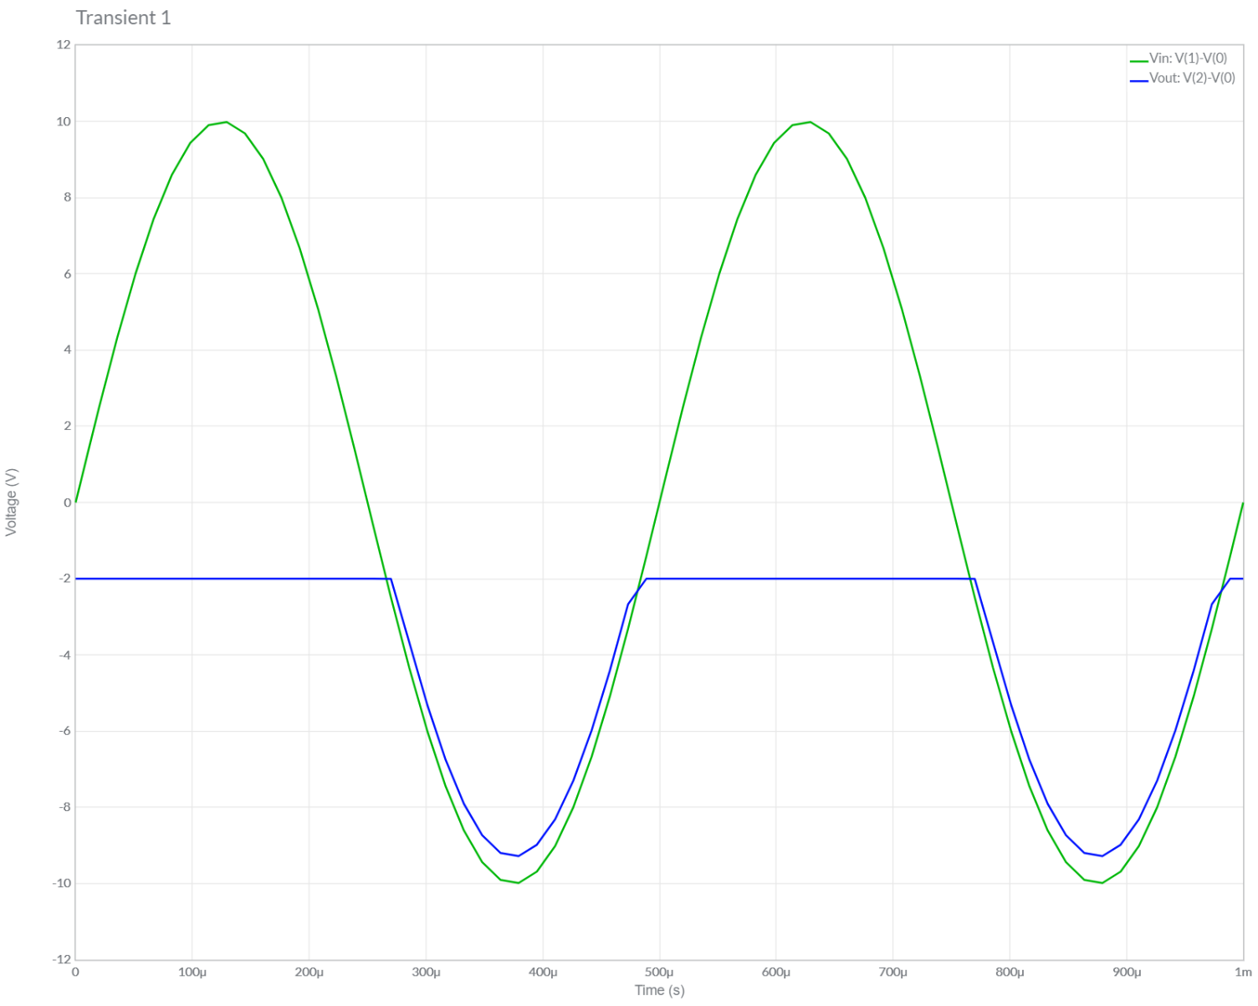

]B.)



I.)Theoretical Calculations:

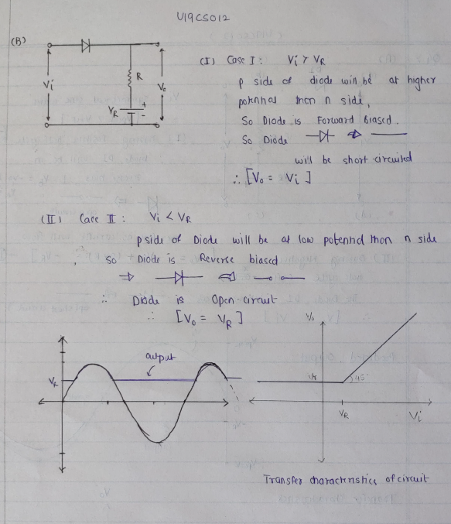

*1.) Circuit Image:*

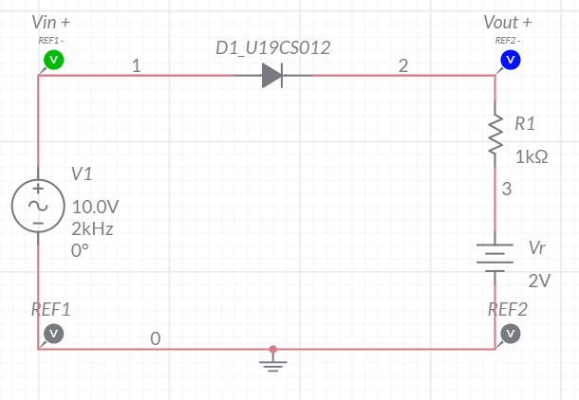

*2.) Grapher Image:*

